Exploratory Data Analysis
For our project, we obtained the data from the Los Angeles Police Department public records along with the U.S. Government Open Data Catalog. Our data consists entirely of structured data and has about 1,004,991 reported crime incidents dates ranging from January 2020 through June 2025. Each observation represents a single crime report and includes 34 variables related to time, location, victim demographics, and crime characteristics.
Before beginning the analysis, the dataset was cleaned to ensure accurate measurement of reporting delays and spatial patterns. We removed any records that contained missing or invalid occurrence/report dates, as the values are required to compute reporting delay. Also, additional filtering was applied to remove records with missing area identifiers for geographic analysis. After cleaning, the dataset decreased to about half its size (444007, 34) but still provided broad coverage across all LAPD areas.
The reporting delay variable was calculated as the difference between the date and time a crime occurred and when it was reported. Multiple time based variables were created such as day, month, and year. We grouped the crimes into violent and non-violent based on the crime code descriptions, and the victim age was categorized into groups to support demographic analysis.
The initial exploration focused on the overall reporting behavior. The figure below shows the distributions of crime occurrence and report dates by year, month, and day. Crime counts show to peak around 2023, with a significant decline in 2024. When analyzing the monthly and daily patterns, they seem to be relatively stable, suggesting that crime reporting does not follow a strong seasonal trend at a broad level.
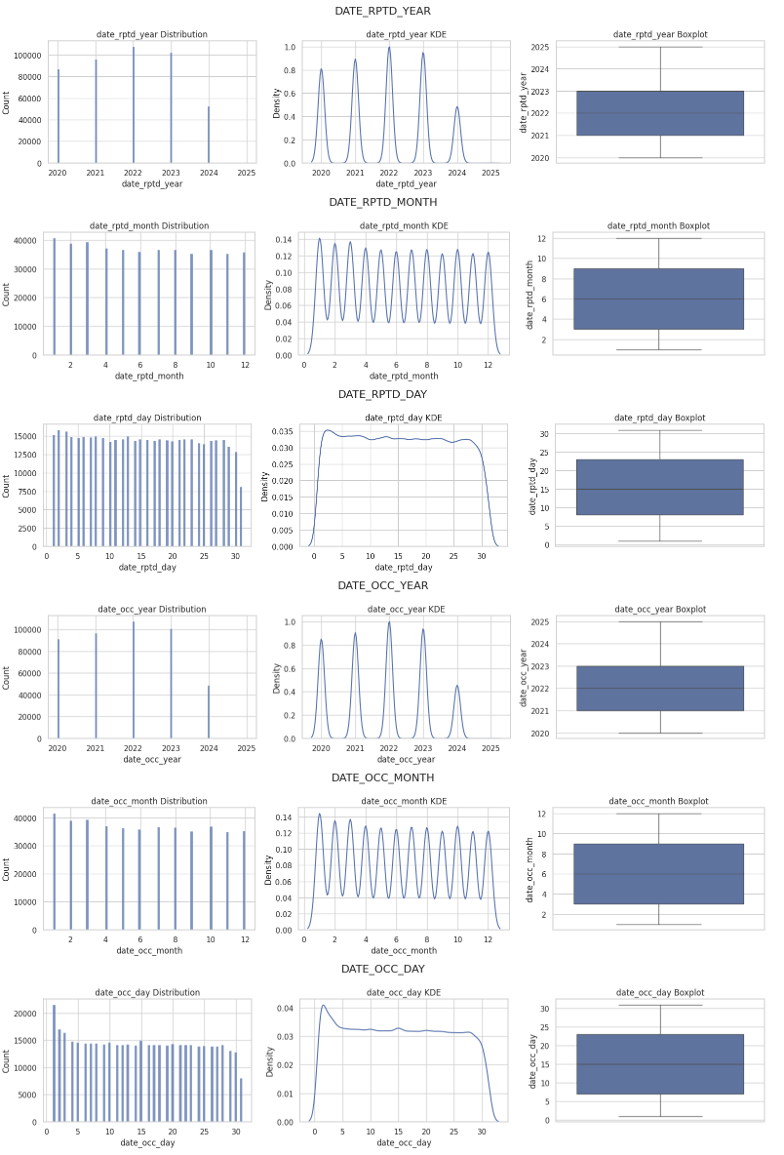
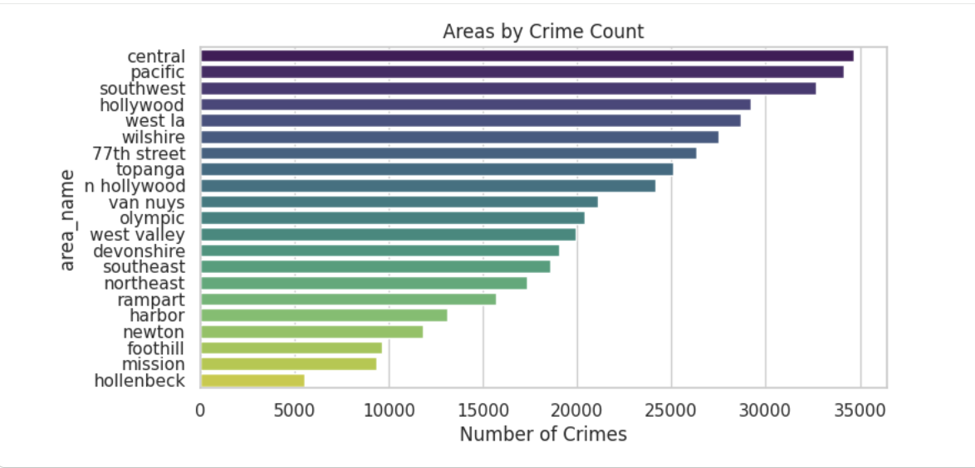
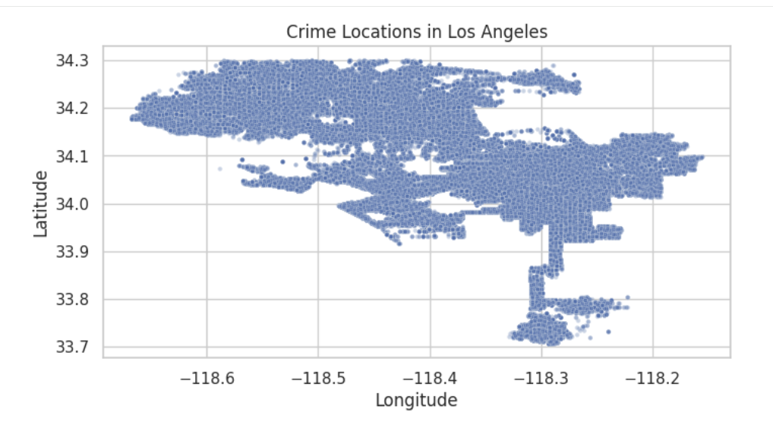
We then explored the geographic distribution of crimes. The figures contain plots of crime locations using latitude and longitude and show that crime incidents are highly concentrated within central Los Angeles rather than evenly distributed across the city. The second graph displays the pattern of total crime counts by LAPD area a little clearer. Areas like Central, Hollywood, and Pacific experience substantially higher crime volumes, whereas areas like Mission and Foothill report fewer incidents. Instead of indicating random fluctuation, these differences point to ongoing spatial vulnerability.

We then examined victim demographics to better understand who is most affected by crime. The histogram and boxplot displays the distribution of victim age and shows a unimodal pattern centered around young and middle aged adults. Crimes involving very young or elderly victims are less common but still present.
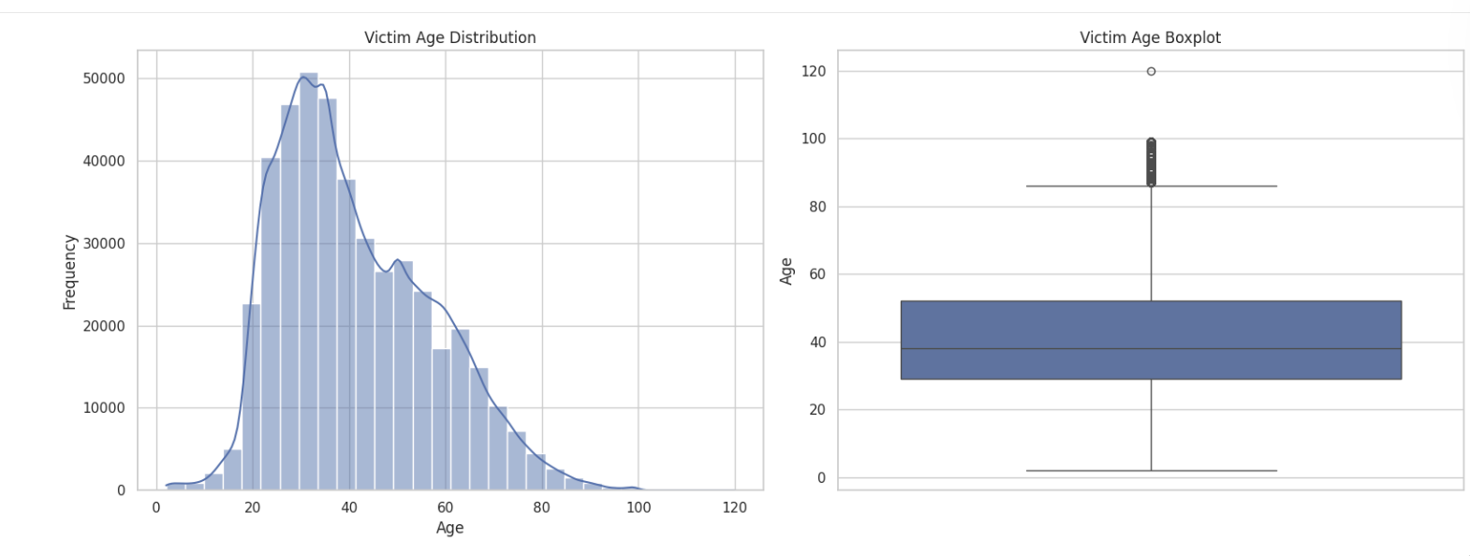
We then created a histogram that displays victim age but broken down by crime type. Clear differences emerge showing that violent crimes tend to involve younger victims, while non-violent crimes, typically fraud related offenses, disproportionately affect older adults.
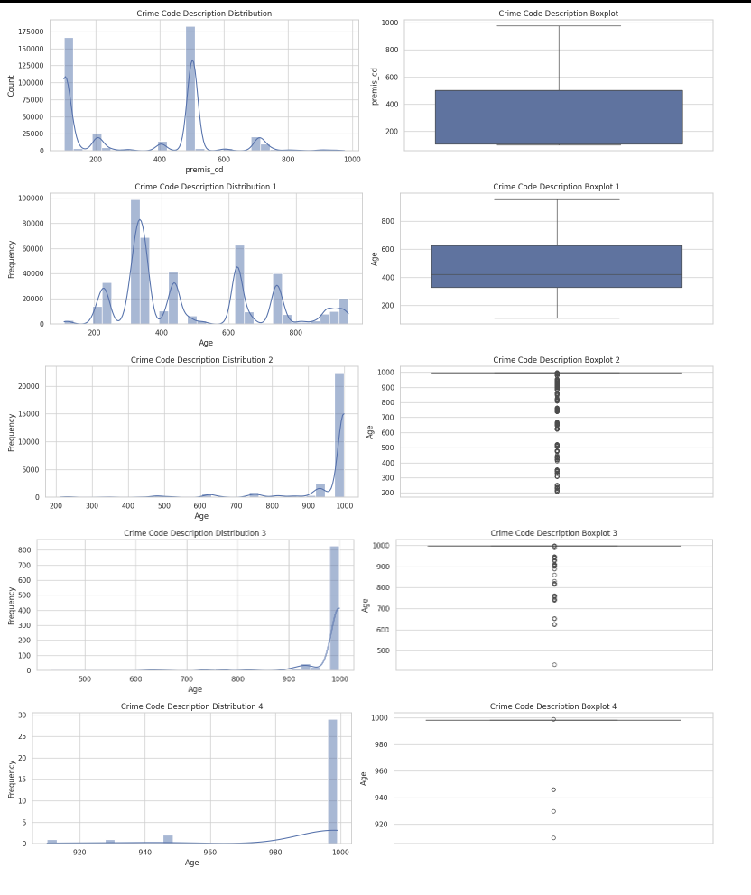
Temporal patterns were also explored. We examined the crime frequency by the hour of occurrence and discovered that incidents peak during evening and late night hours. The table also suggests that time of occurrence may influence how quickly a crime is reported, potentially due to accessibility or perceived urgency.
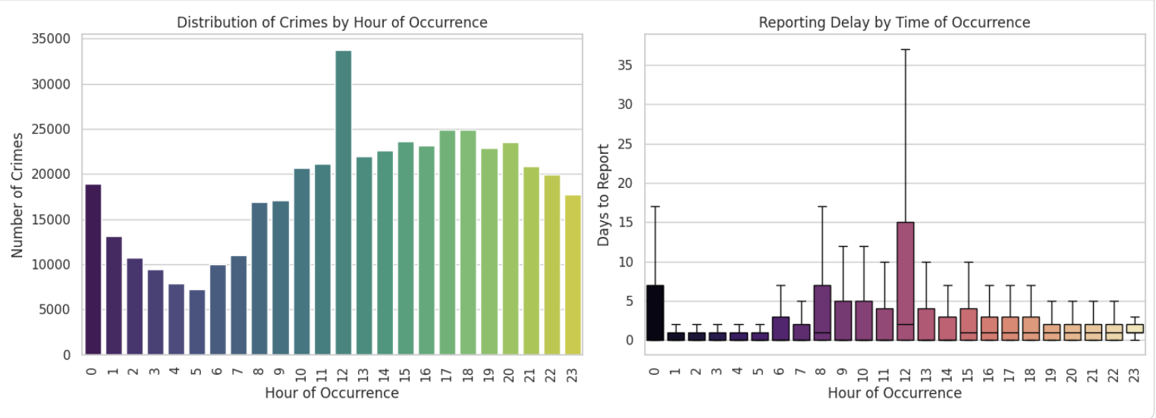
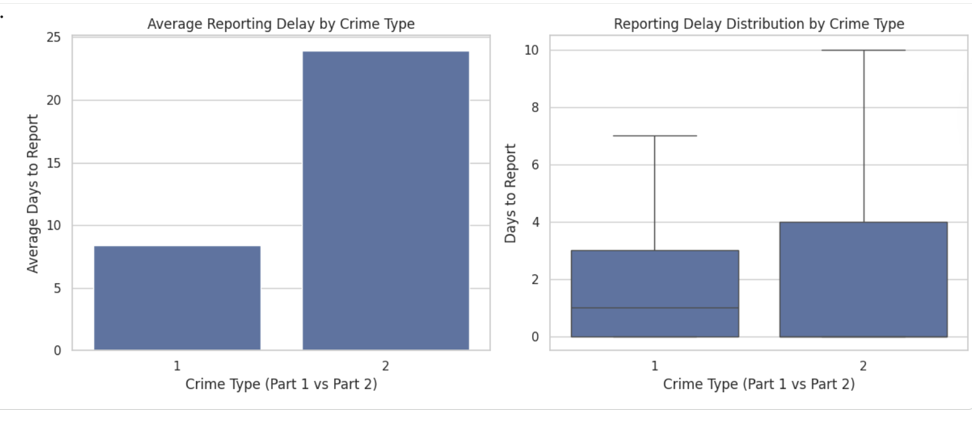
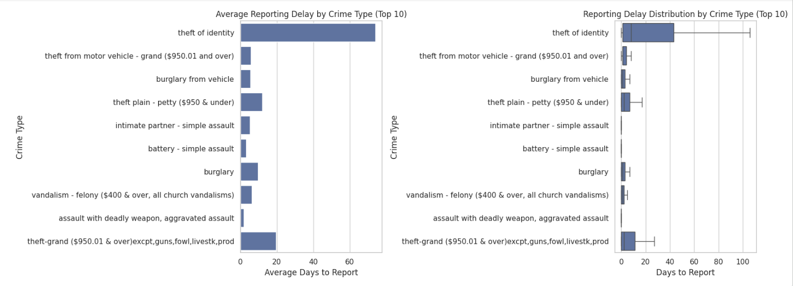
We then examined reporting delay more directly by creating a graph that shows the average reporting delays by LAPD area and reveals meaningful variation between districts. Some areas consistently experience longer reporting delays than others, which may reflect differences in access to reporting resources, community trust or socioeconomic factors. Additionally examined was the reporting delay between violent and non-violent crimes. We found that violent crimes are reported significantly faster and with less variability, while non-violent crimes exhibit longer and more dispersed delays. This pattern provides strong preliminary support for hypothesis 1.

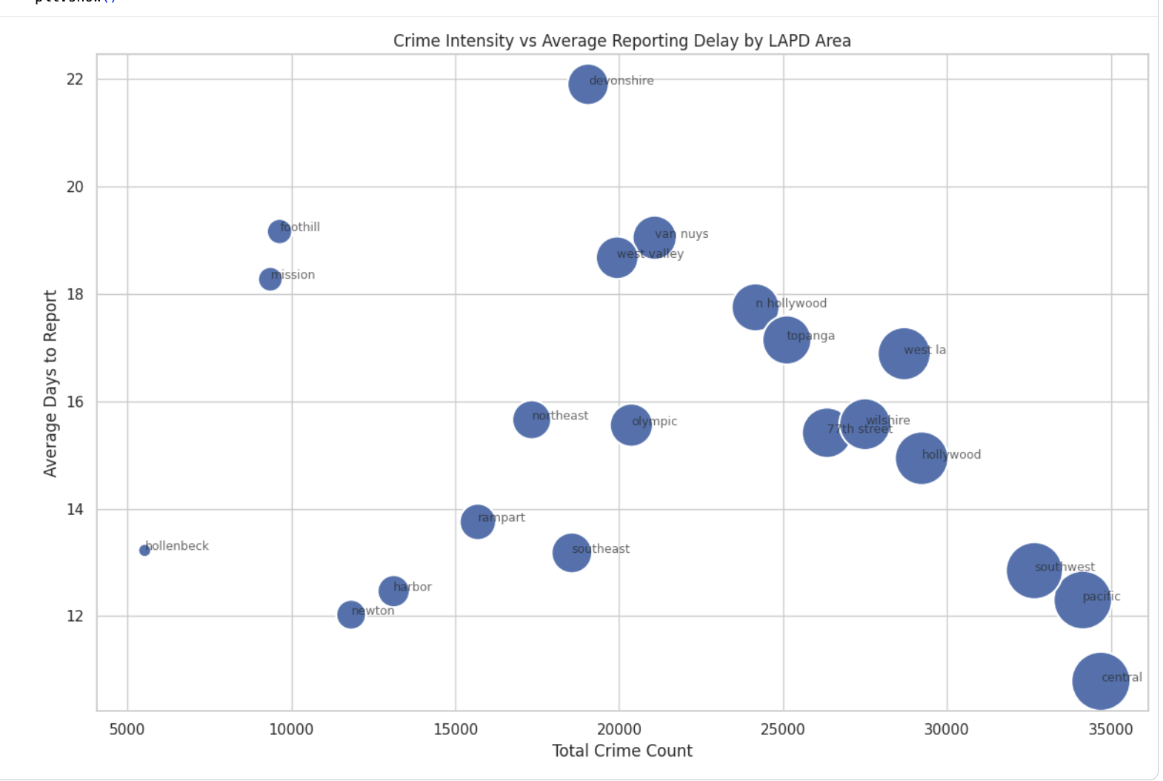
Lastly, the relationship between crime concentration and reporting behavior was explored. The scatterplot displays the relationship between crime concentration and reporting behavior by comparing total crime volume with average reporting delay by LAPD area. While some high crime areas also show longer reporting delays, this relationship is not consistent across all areas. This suggested that crime intensity and reporting behavior are related but distinct processes that should be modeled separately.

From this information, a conclusion can be drawn about relationships between crime type, time of occurrence, geographic location, victim demographics, and reporting behavior. These findings guided the decisions used later in the project and confirm that the dataset contains meaningful structure relevant to all 3 research questions.

Methods

Our attempts at determining the crime reporting delays relied heavily on the data provided by the LAPD and public government data sets. Several preprocessing steps were taken before modeling, including the cleaning of data that did not contain timestamps making it hard to determine reporting delay as well as removing victim ages that were recorded as 0 or implausible values. Reporting delay was calculated as the difference in days between the date a crime occurred and the date it was reported. Exploratory plots show that reporting delay is right skewed, with most incidents reported within a few days but a long tail extending beyond 60 days and because of this skewness, reporting delay was later converted into a classification variable rather than modeled purely as a continuous outcome.
Crime types were also grouped into violent (part 1) and non-violent (part 2) categories based on LAPD crime classifications. Temporal variables including house of occurrence, day of month, and month were extracted from the original date fields and spatial variables were constructed using LAPD area identifiers.
Research Question 1: Predicting Crime Reporting Delays in Los Angeles
Reporting delay was framed as a binary classification problem. Crimes reported within 48 hours were labeled as timely, while crimes reported after 3 days or more were labeled as delayed. Incidents reported between these thresholds were excluded to create clearer and separation between classes. Bar charts and boxplots comparing violent and non-violent crimes show that violent crimes have an average reporting delay of approximately 8 days, while non-violent crimes average over 23 days. The boxplots also show that nonviolent crimes exhibit longer upper tails, proving that delay behavior differs by crime severity.
The time of day plots show that times that occur over night, (between 12am - 5am), tend to have longer median reporting delays than daytime crimes, which supports the inclusion of hour of occurrence as a predictor. Day of month plots show relatively stable averages across most days, with the exception of day1, which exhibits a high mean due to outliers. And because the distributions by day of month are relatively flat, that variable was included but did not dominate model performance.
All results were assessed using a combination of visual diagnostics, numerical metrics, and statistical testing for each research question. Our modeling focused on predicting crime reporting delays in Los Angeles. We ran four models suited for binary classification, including decision tree, random forest, logistic regression, and XGBoost. Model performance was evaluated using accuracy, with the best performing model being XGBoost at 98% accuracy in both training and testing, achieving a 26% improvement over the baseline prediction of 72% accuracy.

Research Question 2: Crime Hotspot Intensity Across Los Angeles
To analyze crime concentration, incidents were aggregated by LAPD area and time period, producing crime counts per area. Exploratory bar charts show that crime is uneven across areas with Central, Pacific, Southwest, and Hollywood, exceeding over 30,000 incidents each, whereas Hollenbeck and Mission had less than 10,000 incidents each.
Scatterplots comparing total crime count and average reporting delay show no strong linear relationship, indicating that crime intensity and reporting behavior should be treated as related but distinct processes.
Crime counts were modeled using count based regression methods. Poisson regression was considered initially but exploratory variance checks suggested overdispersion. As a result, negative binomial regression was used better to account for excess variance in crime counts.
The temporal heat maps also show that crime intensity peaks during evening and late night houses, specifically between 6pm and 12 am, and that high crime areas remain consistently high over the years.

Research Question 3: Victim Age Patterns in Los Angeles Crime
Victim age was modeled both as continuous variable and as grouped categories such as children, young adults, middle aged, and seniors). Histograms show a unimodal age distribution centered around the late 30’s with a median victim age near 38-40 years. Box plots reveal a right tail extending into older ages with seniors appearing as less frequent but meaningful outliers.
Plots comparing victim age by crime type show that violent crimes skew younger while non violent crimes such as fraud and identity theft skew older. Time of day plots further show that late night crimes disproportionately involve younger victims, while daytime crimes more frequently affect middle aged and older individuals.

